NAME………………………….………………. ADMN NO. .……….………………….

DATE …………………… SIGNATURE …………………………
232/1
PHYSICS
PAPER 1
TIME: 2 HOURS.
DECEMBER 2021
SECTION A: 25 MARKS
- The figure below shows a part of micrometer screw gauge with a zero error of -0.04mm. Write down the exact length measured. (2 marks)
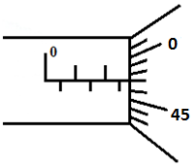
2.97mm + 0.04=3.01mm ( 1 mk for 2.97 and 2nd mark for 3.01mm)
- The following figure shows a rod made of wood on one end and metal on the other end suspended freely with a piece of thread so that it is in equilibrium.

The side made of metal is now heated with a Bunsen flame. State and explain the observation that will be made after some time. (2marks)
he bar tilts in the anti-clockwise direction. Position of cog shifts to the left due to expansion
- Estimate the size of an oil molecule if a drop of oil of volume 6.0 × ${10}^{-10}$ m³ forms a patch of diameter 32 cm on a water surface. (2marks)
t=v/a =6x10⁻¹⁰
3.142x0.16² = 7.459x10⁻⁹ m
- An immersion heater rated at 180W is placed in a liquid of mass 2kg. When the heater is switched on for 7.5 minutes the temperature of the liquid rises by 40ºC. Determine the specific heat capacity of the liquid. (3marks)
Pt=mcΔT C=Pt/mΔT =180x7.5x60/2x40 = 1,012.5 J/kg/K
- Other than increase in temperature state one other way of lowering the surface tension of a liquid. Addition of impurities (1mark)
- The figure below shows a uniform bar pivoted at its centre and is at equilibrium. (3marks)
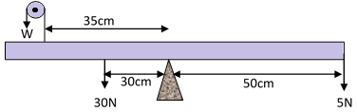
Determine the value of w.
am= cm
30x0.3=W x 0.35 + 5 x 0.5 W=18.57N

7.(i) Sketch a velocity – time graph on the axes provided for an object thrown vertically upwards with initial velocity $20 {ms}^{-1}$ and takes 2 seconds to reach maximum height. (1mark )

Velocity
Ms⁻¹

$20$

0 1 2 3 4 5 6
time(s)
(ii) Calculate the maximum height attained by the object in 7 (i) above ( 2 marks)
S =ut-1/2gt²
= 20x2 – 1/2x10x2²
= 20 m
8. In an experiment to demonstrate Brownian motion, smoke was placed in a smoke cell and observed under a microscope. State and explain the observation. (2mark)
Bright specks are seen moving in a continuous random motion. This was due to continuous collision between the invisible air molecules and smoke particles
9. State a reason why a burn from steam at 1000C is more severe than a burn from boiling water at the same temperature (1 mark)
Steam contains latent heat of vaporization which the boiling water doesn’t have.
10. Explain why the rate of heat flow in a conductor increases with increase in cross-section area. ( 1 mark )
An increase in cross section area leads to an increase in the number of conducting particles free electrons/vibrating particles) per unit length hence the increase in thermal conductivity.
11.A piece of paper is held in front of the mouth and air blown horizontally over the paper, it is observed that the paper get lifted up. Give reason for the observation. (1mark)

When air is blown, the velocity of the air increases which make the pressure to reduce below atmospheric pressure. Air pressure below the paper is therefore greater and lifts the paper

12. In the study of free fall, it is assumed that the gravitational force F acting on a given body of mass, is given by F = mg. State two other forces that act on the same body. (2marks)
Upthrust
Viscous drag
13.A girl in a school in Nakuru plans to make a barometer using a liquid of density 1.25gcm⁻³. If the atmospheric pressure in the school is 93750Nm⁻². Determine the minimum length of the tube that she will require? ( 2 marks)

Pa=ρgh h=Pa/ρg =93750/12500

SECTION B (55MARKS)
ANSWER ALL QUESTIONS IN THIS SECTION

- a) (i) State Archimedes’ Principle. (1mk)

When a body is partially or fully immersed in a fluid it experiences an upthrust forces equal to the weight of the fluid displaced.
(ii) A metal block weighs 1.04N in air, 0.64N when fully immersed in water and 0.72N when fully immersed in a liquid. If the density of water is 1000 kg m⁻³, find:

- The density of the liquid. (2mks)
1.04-0.64=0.4N
1.04-0.72= 0.32N
RD = 0.32/0.4 =0.8x1000= 800kg/m³

- The density of the metal block. (3 mks)
U=ρgV V=U/ρg=0.4/10000 =
W=mg m=W/g =1.04/10 ρ = m/V=0.104x10000/0.4 =2,600kg/m³
b) A crane lifts a load of 2000 kg through a vertical distance of 3.0m in 6 seconds.
Determine the;
- Work done by the crane. (2marks)

W=Fd=20000x3 =60,000 J

ii) Power developed by the crane. (2mks)

P=W/t =60,000/6 =10000W

iii) Efficiency of the crane given that it is operated by an electric motor rated 12.5kW. (2mks)
Π = power output / power inputx100%
=10000/12500x100= 80%
15. (A) The figure below shows a hydraulic brake system.
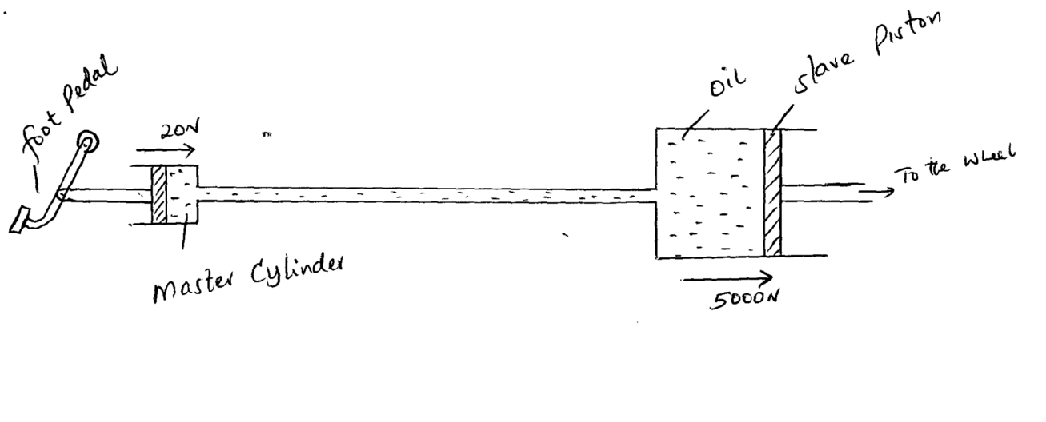
A force of 20 N is applied on the foot pedal connected to a master cylinder piston of area 500cm². This causes a stopping force of 5000N on one wheel. Calculate.

- Pressure in the master cylinder (2 marks)

P=F/A =20/500 x 10000 = 400N
- Area of the slave cylinder piston. ( 2 marks)

A=F/P =5000/400 = 12.5m²
- Velocity ratio of the system. ( 2 marks)

VR=A/a =12.5/0.05 =250
B) I) State the reason why a body in uniform circular motion is said to be accelerating. (1 mark)
Direction of velocity keeps on changes at any instant

II) A particle moving along a circular path of radius 5cm describes an arc of length 2cm every second. Determine:
- Its angular velocity. (1mark)
V=2cm/s ω= v/r=0.02/0.05=0.4 rad/s
- Its periodic time. (2marks)
T=2Л/ω = 2x3.142/0.4 =15.71s
c) A stone of mass 150g is tied to the end of a string 80cm long and whirled in a vertical circle at 2rev/s. Determine the maximum tension in the string. (3marks)
ω=2x2π = 4π rad/s
F=mω²r = 0.15x(4π)²x 0.8 = 18.95N
T=F + mg = 18.95 + 1.5 = 20.45N
(d) State one factor affecting centripetal force (1mark)
Mass of the object/radius of rotation/speed of rotation

a) Define “specific heat capacity” of a substance (1mark)
Quantity of heat energy required to raise the temperature of a unit mass of a substance by 1K

b) In an experiment, an aluminum block of mass 2kg was heated using an immersion heater as shown in figure below.
A
(+)
(-)
V
Thermometer
Aluminium block
Insulating cover

The temperature of the block was recorded every minute for exactly five minutes and then the heater was switched off. A graph of temperature in ºC against time in minutes for the experiment is shown below.
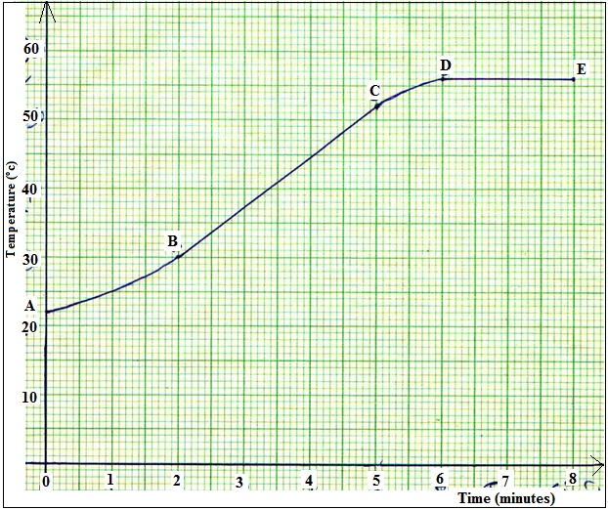

Using the graph, Suggest why;
- The reading in the thermometer rose relatively slowly between point A and B. (1mark)
Some of the heat is used to warm the insulating cover and surrounding area
- The temperature continued to rise after the heater was switched off (1mark)
The heater was still hot (at a higher temperature than the block/continues heating as to cools
- Use the straight portion of the graph (B to C) to calculate the specific heat capacity of the aluminum given that the voltmeter reads 22.00 V and ammeter 10A throughout the course of the experiment. (3 marks)
Power supplied= IV=10x22=220W1
Slope=$\frac{}{t}=\frac{52-30}{(5-2)(60)1}=\frac{22}{180}{0c}/s$
Pt=McΔθ
M=2kg
C=$\frac{p}{m}x\frac{t}{}=\frac{220}{2}x\frac{180}{22}=900J/{kgK1}$
- Giving a reason explain why the value calculated in b) (iii) will not be accurate. (1 mark)

Heat lost to the surrounding,1 heat used to warm up the insulating cover and thermometer1 is not taken into account.
- A faulty thermometer reads 40⁰Cwhen dipped in pure melting ice and 240⁰C when in contact with steam above pure boiling water. What would the same thermometer read when put in water at 50⁰C? ( 2 marks)

100⁰
50⁰
0⁰
240⁰
X⁰
40⁰
$\frac{100-0}{240-40}$= $\frac{50-0}{X-40}$√1

$\frac{100}{200}$ = $\frac{50}{X-40}$√1
= 140⁰

- (a) A stone is thrown horizontally with a velocity of 45m/s from the top of a vertical tower 50m high. Determine:
- The time taken by the bullet to reach the bottom of the tower (2 mks)

S=Ut +1/2gt², 50=1/2x10t² t=3.16s

- The maximum horizontal distance covered by the bullet (2mks)

R=ut R=45x3.16=142.2m

b) i) Distinguish between elastic and inelastic collision. (1mark)
Elastic is where both kinetic energy and linear momentum are conserved while inelastic is where only linear momentum is conserved.
ii) A car of mass 800 kg collides heads on with a truck of mass 5000kg travelling at 40 m/s. The car is thrown to the bonnet of the truck which continues to move after impact at 10 m/s in the original direction. How fast was the car moving? (3marks)
m₁u₁-m₂u₂=(m₁+m₂)vc
(5000x40) – 800xU₂=(5000+800) 10
200,000 – 800U₂ = 58,000
U₂ = 142,000/800 =177.5 m/s

18. Figure below shows the apparatus that a student used to investigate the relationship between temperature and pressure of a fixed mass of a gas at constant volume.
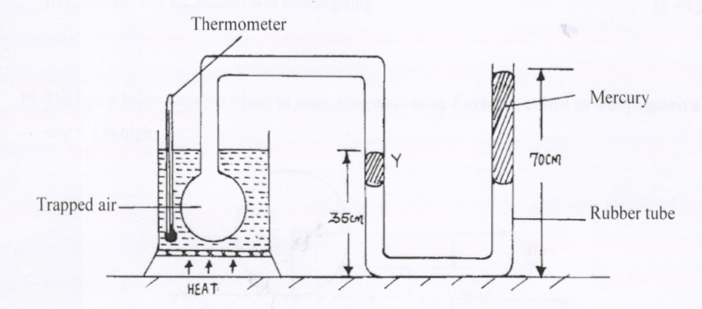

a) i) Describe how the student should ensure that all air trapped has the same temperature as indicated by the thermometer. (1 mark)
Constant and thorough stirring to ensure that the heat supplied is evenly distributed in the water.
ii) Give a reason why it is necessary to ensure that before taking any reading on pressure, the liquid level should reach the level marked Y. (1 mark)

This ensures that the volume of the trapped air doesn’t change (remains constant)

(b) The pressure P of a fixed mass of a gas at a constant temperature of T = 200K is varied continuously and values of corresponding volume recorded. A graph P against $\frac{1 }{V }$is shown on grid below.
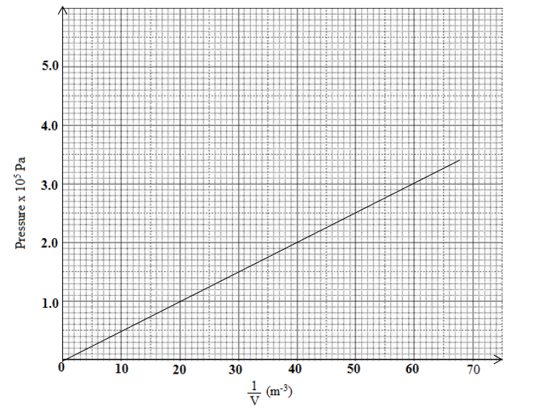

- Determine the gradient of the graph. (2 marks)

M=3-1/60-20 =2x10⁵/40
=5,000 Pa/m⁻³

- Find the value of R given that the pressure P and volume V of the gas are related by the equation$T=\frac{PV}{2R}$ , where R is a constant (3 marks)

Y=mx+c
P=2RT/V M=2RT R=M/2T =5,000/2x200 = 12.5 Pa/K/m⁻³

(c) The pressure of the air inside a car tyre increases if the car stands out in the sun for some time on a hot day. Explain the pressure increase in terms of the kinetic theory of gases. (2 marks)
- Particles gain heat energy which increases their kinetic energy/ Increased speed of the particles
- Increased rate of collisions between particles and walls of the tyre hence increase in pressure

(d) A gas is put into a container of fixed volume at a pressure of 3.6 x 10⁵ Nm⁻² and temperature 27°C. The gas is then heated to a temperature of 177°C. Determine the new pressure (3 marks)

P₁=3.6x10⁵
T₁=273+27=300K
P₂= ??
T₂= 273+177= 450K

P₁/T₁=P₂/T₂

P2= 3.6x10⁵x450/300 = 5.4x10⁵N/m²

End.!

